Execution of springboot-swagger example:

<http://localhost:8081/api/javatech>

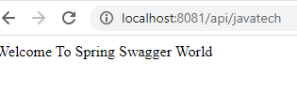

<http://localhost:8081/swagger-ui.html>

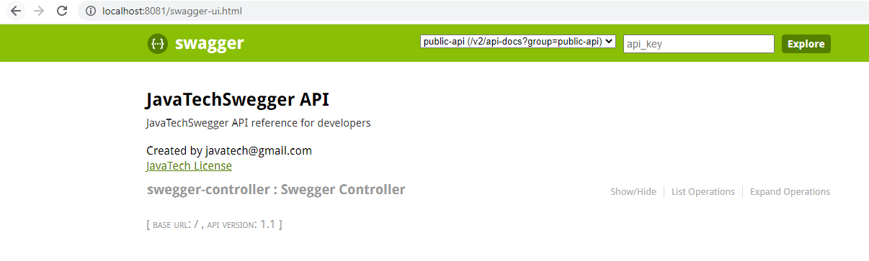

If you click on the show/hide link in above page then ui will look like as below:

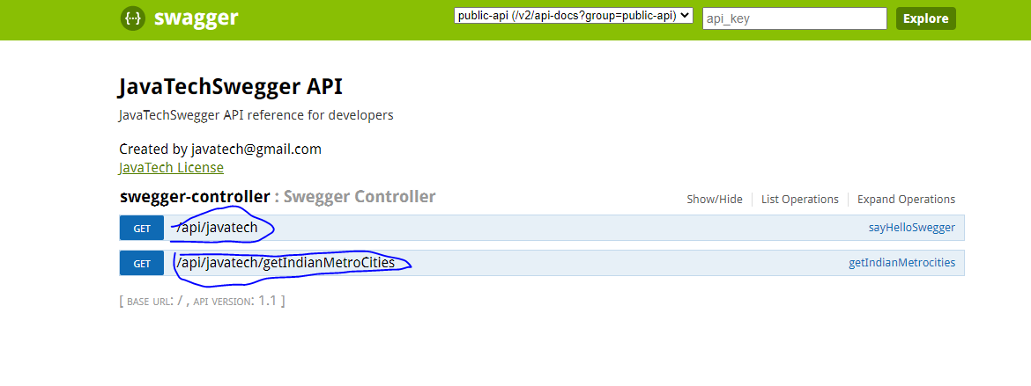

It will list the number of end point exposed via this service ( i.e.Controller)

Now If you click on

### [GET](http://localhost:8081/swagger-ui.html#!/swegger-controller/getIndianMetrocitiesUsingGET) [/api/javatech/getIndianMetroCities](http://localhost:8081/swagger-ui.html#!/swegger-controller/getIndianMetrocitiesUsingGET)

Then it will appear like this

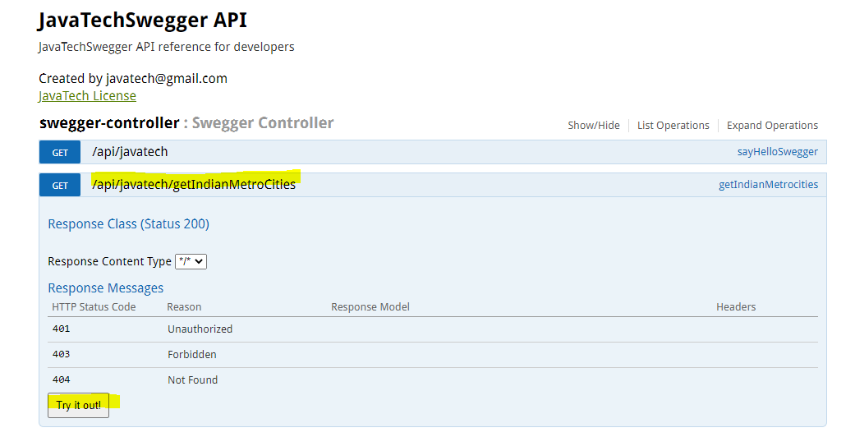

Once you click the try it out button then it will having below details of API

